SMART PARKING

PHASE3: DEVELOPMENT PART 1:

Building an IOT sensor system with Raspberry Pi integration to hit upon parking area occupancy the use of ultrasonic sensors entails both hardware and software program additives. Here's a step-by means of-step guide to help you get started:

Hardware additives:

Raspberry Pi (any model with GPIO pins) Ultrasonic distance sensors (e.g, HC-SR04) Jumper wires

Breadboard (non-compulsory) Energy supply for Raspberry Pi

Net connectivity (wireless or Ethernet)

# Software additives:

Raspberry Pi OS (e.g Raspbian) Python (pre-installed on Raspberry Pi)

RPi.GPIO library (for controlling GPIO pins) Google Sheets (for storing and visualizing facts)

Google Sheets API (for programmatic get admission to to Google Sheets)

# Setup Raspberry Pi:

Installation Raspberry Pi OS to your Raspberry Pi. Connect it to the internet, both via wi-fi or Ethernet.

# Connect Ultrasonic Sensor:

Connect the VCC pin of the ultrasonic sensor to a 5V pin at the Raspberry Pi. Connect the GND pin to a floor pin at the Raspberry Pi.

Join the TRIG pin to a GPIO pin (E.G., GPIO 17).

Connect the ECHO pin to some other GPIO pin (E.G., GPIO 18). You may use a breadboard to make the connections.

# Datagram:

For raspberry pi w:

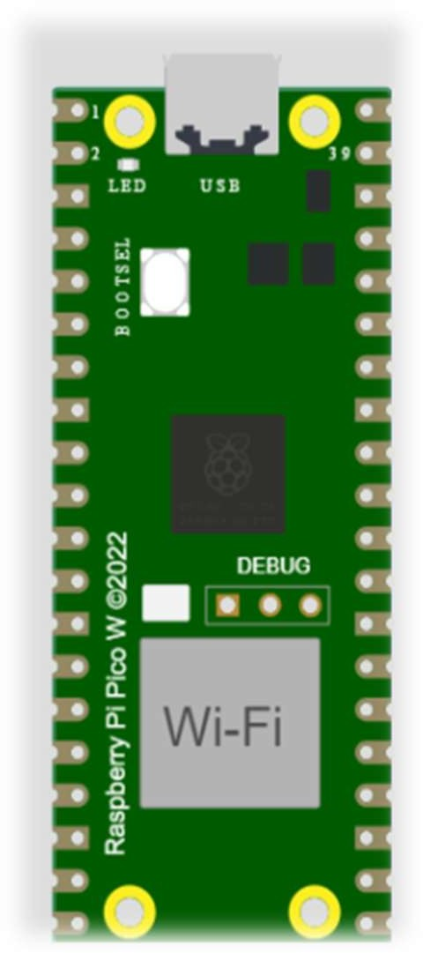

# Simulate module:

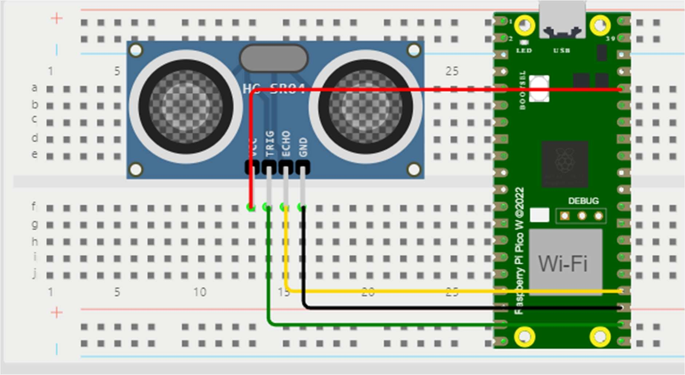

Python scripts for raspberry module:

import RPi.GPIO as GPIO import time

import gspread

from oauth2client.service_account import ServiceAccountCredentials

# Set up Ultrasonic Sensor GPIO pins TRIG_PIN = 17

ECHO_PIN = 18

# Initialize GPIO GPIO.setmode(GPIO.BCM) GPIO.setup(TRIG_PIN, GPIO.OUT)

GPIO.setup(ECHO_PIN, GPIO.IN)

# Define Google Sheets-related variables

credentials_file = 'smart-parkingiot-095b74826f5a' # Replace with your credentials file

google_sheets_name = 'parkingdata' # Replace with your Google Sheets document name

sheet_name = 'Sheet1' # Replace with your sheet name

# Initialize Google Sheets

scope = ['https://[www.googleapis.com/auth/spreadsheets'](http://www.googleapis.com/auth/spreadsheets%27)] credentials =

ServiceAccountCredentials.from_json_keyfile_name(credentials_file, scope) gc = gspread.authorize(credentials)

worksheet = gc.open(google_sheets_name).worksheet(sheet_name)

try:

while True:

# Measure distance using ultrasonic sensor GPIO.output(TRIG_PIN, False) time.sleep(2)

GPIO.output(TRIG_PIN, True) time.sleep(0.00001) GPIO.output(TRIG_PIN, False)

while GPIO.input(ECHO_PIN) == 0: pulse_start = time.time()

while GPIO.input(ECHO_PIN) == 1: pulse_end = time.time()

pulse_duration = pulse_end - pulse_start

distance = pulse_duration * 17150 # Speed of sound (343 m/s)

# Get current timestamp

timestamp = time.strftime("%Y-%m-%d %H:%M:%S")

# Determine occupancy status based on distance threshold distance_threshold = 50

occupancy_status = "Occupied" if distance < distance_threshold else "Vacant"

# Log data to Google Sheets

worksheet.append_row([timestamp, distance, occupancy_status])

print(f"Timestamp: {timestamp}, Distance: {distance} cm, Occupancy:

{occupancy_status}")

time.sleep(5) # Adjust the time interval as needed

except KeyboardInterrupt: GPIO.cleanup()

# Web java script code:

// JavaScript code to process CSV data and update the website Papa.parse('parkingdata.csv', {

download: true, header: true, skipEmptyLines: true, dynamicTyping: true,

complete: function(results) { const data = results.data;

// Initialize counts let vacantCount = 0;

let occupiedCount = 0;

// Process the data and calculate counts data.forEach((entry) => {

const status = entry['status'];

if (status === 'vacant') { vacantCount++;

} else if (status === 'occupied') { occupiedCount++;

}

});

// Update the HTML with the counts

document.getElementById('vacantCount').textContent = vacantCount; document.getElementById('occupiedCount').textContent =

occupiedCount;

}

});

# Parking datasheet: Parkingdata.csv

|  |  |  |  |
| --- | --- | --- | --- |
| S.NO | Timestamp | Distance(cm) | status |
| 1 | 1/1/2023 11:00 | 50 | Occupied |
| 2 | 1/1/2023 11:10 | 233 | Vacant |
| 3 | 1/1/2023 11:30 | 315 | Vacant |
| 4 | 1/1/2023 12:00 | 233 | Vacant |
| 5 | 1/1/2023 12:00 | 108 | Vacant |
| 6 | 1/1/2023 12:00 | 50 | Occupied |
| 7 | 1/1/2023 12:00 | 344 | Vacant |
| 8 | 1/1/2023 12:00 | 400 | Vacant |
| 9 | 1/1/2023 12:00 | 112 | Vacant |
| 10 | 1/1/2023 12:00 | 50 | Occupied |
| 11 | 1/1/2023 12:00 | 50 | Occupied |
| 12 | 1/1/2023 12:00 | 124 | Vacant |
| 13 | 1/1/2023 12:00 | 50 | Occupied |
| 14 | 1/1/2023 12:00 | 222 | Vacant |
| 15 | 1/1/2023 12:00 | 50 | Occupied |
| 16 | 1/1/2023 12:00 | 312 | Vacant |
| 17 | 1/1/2023 12:00 | 50 | Occupied |
| 18 | 1/1/2023 12:00 | 200 | Vacant |
| 19 | 1/1/2023 12:00 | 50 | Occupied |
| 20 | 1/1/2023 12:00 | 213 | Vacant |
| 21 | 1/1/2023 12:00 | 50 | Occupied |
| 22 | 1/1/2023 12:00 | 200 | Vacant |
| 23 | 1/1/2023 12:00 | 400 | Vacant |
| 24 | 1/1/2023 12:00 | 253 | Vacant |
| 25 | 1/1/2023 12:00 | 50 | Occupied |
| 26 | 1/1/2023 12:00 | 123 | Vacant |
| 27 | 1/1/2023 12:00 | 50 | Occupied |
| 28 | 1/1/2023 12:00 | 105 | Vacant |
| 29 | 1/1/2023 12:00 | 50 | Occupied |
| 30 | 1/1/2023 12:00 | 100 | Vacant |

Tracking and Visualization:

Get right of entry to your Google Sheets document to reveal parking area occupancy.

Use Google Sheets capabilities for statistics analysis and visualization.

Hardware Setup:

Securely mount the ultrasonic sensors inside the parking place.

Make sure they have got an unobstructed view of the parking spaces.

# Scaling:

For large parking areas, you can want a couple of Raspberry Pis and sensors.

Every Raspberry Pi can log information to a vital Google Sheets record or a separate record for its region.

# Preservation and power:

Ensure the Raspberry Pi has a reliable energy supply. Periodically check and preserve the sensors and connections.

This setup permits you to create a smart parking system that constantly video display units parking space occupancy and logs the statistics in a Google Sheets report for real-time tracking and evaluation.

**THAKYOU**